Heat of Hydration Cement
 | Dewar Flask  Code: 38-4600/10  Attributes: Description = Dewar Flask  Standards: BS 4550

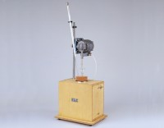 | Heat of Hydration Apparatus  Code: 38-4600/01  Attributes: Description = Heat of Hydration Apparatus, Power Supply = 220 - 240 V AC, 50 - 60 Hz, 1 ph  Standards: BS 4550

Beckman Thermometer and Reader Glass
Code: 38-4600/12
Attributes: Description = Beckman Thermometer and Reader Glass
Standards: BS 4550

Glass Paddle for Stirrer
Code: 38-4600/13
Attributes: Description = Glass Paddle for Stirrer
Standards: BS 4550

