BS/EN compaction test 2.5kg
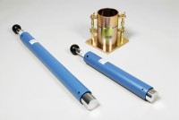 | BS Standard Compaction Mould 1000Cm Capacity.  Code: 24-9000  Attributes: Description = Standard compaction mould, Construction = Steel  Standards: BS 1377-4, BS 1924-2, EN 1997-2

Standard Compaction Rammer 2.5Kg BS1377-1975
Code: 24-9002
Attributes: Description = Standard compaction rammer, Finish = Corrosion resistant
Standards: BS 1377-4, BS 1924-2, EN 1997-2

