Vibrating Table
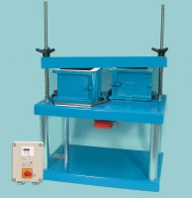 | Vibrating Table 600 X 400mm Table Top. 220-240V 50Hz 1Ph.. Supplied with clamping assm.  Code: 34-6250/01  Attributes: Voltage Supply = 220 - 240 V AC, 50 Hz, 1 ph  Standards:

