ELE Bouyancy Balance
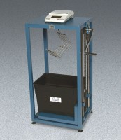 | ELE Buoyancy Balance  Code: 34-8100/02  Attributes: Frame = Heavy-duty steel frame construction with<br>mechanical lifting device and suspension hook., Description = ELE Buoyancy Balance  Standards:

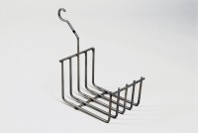 | Cradle  Code: 34-8105  Attributes: Description = Cradle, Weight, lbs = 1.24  Standards: EN 12697-32, EN 13280-4, BS 598-104

