Pundit Lab
 | Ultrasound Couplant Supplied In 250ml bottle  Code: 35-2305  Attributes: Description = Ultrasound Couplant  Standards:

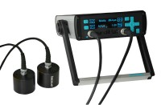 | Pundit Lab Ultrasonic Concrete Tester 110-240V 50/60Hz 1Ph  Code: 35-2302/09  Attributes: Description = Pundit Lab Ultrasonic Concrete Tester, Dimensions, l x w x h, ” = 12x18x6  Standards:

