Hand Vane Tester
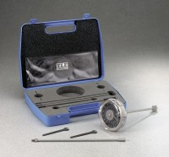 | Hand Vane Tester  Code: 26-3346  Attributes: Description = Hand Vane Tester  Standards: ASTM D2573, ASTM D4648

33 mm Diameter Vane and Carry Case
Code: 26-3346/10
Attributes: Diameter, ” = 33 mm, Description = 33 mm Diameter Vane and Carry Case
Standards: ASTM D2573, ASTM D4648

