Field density tools
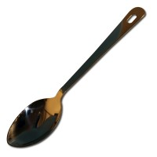 | Density Spoon.  Code: 29-5000  Attributes: Description = Density Spoon, Weight, kg = 0.11  Standards:

 | Soft Headed Mallet.  Code: 29-5020  Attributes: Description = Soft Headed Mallet, Weight, kg = 0.62  Standards:

Density Chisel.
Code: 29-5060
Attributes: Description = Density Chisel, Weight, kg = 0.75
Standards:

Metal Dibber Tool
Code: 29-5080
Attributes: Description = Metal Dibber Tool, Weight, kg = 0.27
Standards:

Density Hand Pick.
Code: 29-5120
Attributes: Description = Density Hand Pick, Weight, kg = 0.76
Standards:

Steel Pointed Rod.
Code: 29-5140
Attributes: Description = Steel Pointed Rod, Weight, kg = 0.25
Standards:

