Rice Test Vibrator
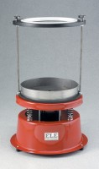 | Rice Test Vibrator  Code: 45-9315/01  Attributes: Description = Rice Test Vibrator 220 - 240 V AC 50 Hz, Dimensions, h x dia, ” = 19-1/2 x 12  Standards: EN 12697-5, ASTM D2041, AASHTO T209

 | Rice Test Vibrator 115vAC, 50/60 Hz  Code: 45-9315/02  Attributes: Description = Rice Test Vibrator 115 V AC 50/60 Hz, Dimensions, h x dia, ” = 19-1/2 x 12  Standards: ASTM D2041, AASHTO T209

Attachment Required for 6000 g
Code: 45-9315/10
Attributes: Description = Attachment required for Rice Test Vibrator
Standards: EN 12697-5

