Soundness
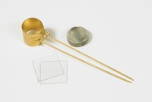 | Le Chatelier Mould  Code: 38-3005  Attributes: Description = Le Chatelier Mould, Weight, kg = 0.9  Standards: BS 6463, EN 196-3, EN 459-2

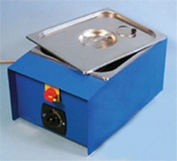 | Le Chatelier Water Bath  Code: 38-3420/01  Attributes: Description = Le Chatelier Water Bath, Power Supply = 220 - 240 V AC, 50 - 60 Hz, 1 ph  Standards:

