Wet Washing Spray Attachment
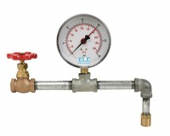 | Wet Washing Spray Attachment  Code: 79-7040  Attributes: Fittings = Standard Pipe, Description = Wet Washing Spray Attachment  Standards: ASTM C115, ASTM C430

