Expansion Index Test Apparatus
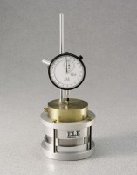 | Expansion Index Test Apparatus  Code: 25-0380  Attributes: Test Time, hours = 24, Description = Expansion Index Test Apparatus  Standards: ASTM D4829, California UBC 29-2

