Accessories for BS compaction and CBR
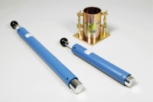 | BS Standard Compaction Mould 1000Cm Capacity.  Code: 24-9000  Attributes: Description = Standard compaction mould, Construction = Steel  Standards: BS 1377-4, BS 1924-2, EN 1997-2

 | BS Cbr Mould Body.  Code: 24-9198  Attributes: Description = CBR mould body, Base Plate = Solid  Standards: BS 1377, BS 1924, EN 13286-4, EN 1997-2

BS Extension Collar
Code: 24-9200
Attributes: Description = CBR extension collar, Base Plate = Solid
Standards: BS 1377, BS 1924, EN 13286-4, EN 1997-2

BS Solid Base or Top Plate
Code: 24-9204
Attributes: Description = BS CBR solid base, Base Plate = Solid
Standards: BS 1377, BS 1924, EN 13286-4, EN 1997-2

