Digital Residual Pressure Manometer Non-toxic
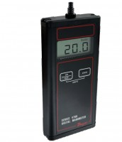 | Residual Pressure Manometer  Code: 45-9330  Attributes: Description = Residual Pressure Manometer  Standards: ASTM D2041, EHS 9300, AASHTO T209, AASHTO T283

