Asphalt Compaction Mould
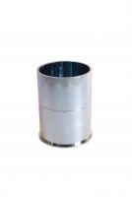 | Compaction Mould  Code: 45-6310  Attributes: Description = Compaction Mould, Dimensions, i.d x int. ht. = 4" (101.6 mm) i.d. x 3" (76.2 mm) internal h. with base  Standards: EN 12697-30, ASTM D6926, AASHTO T245

