Slump Test
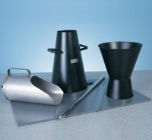 | Tamping Rod 16mm Dia X 600mm Long Hemispherical At Both Ends.  Code: 34-0130  Attributes: Description = Tamping Rod, Weight, kg = 0.95 kg  Standards:

300 mm Stainless Steel Rule.
Code: 34-0140
Attributes: Description = Steel Rule, Weight, kg = 0.06 kg
Standards:

Base Plate for Slump Test.
Code: 34-0160
Attributes: Description = Base Plate, Weight, kg = 2 kg
Standards:

Slump Test Set BS & ASTM. C/W Slump Cone Base Plate Steel Rule Tamping Rod & Funnel.
Code: 34-0192
Attributes: Description = Slump Test Set, Weight, kg = 6.87 kg
Standards:

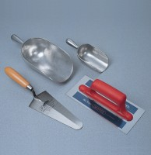 | Aluminium Scoop Large  Code: 81-0220  Attributes: Description = Large Aluminium Scoop, Weight, kg = 0.294 kg  Standards:

Slump Cone
Code: 34-0110
Attributes: Description = Slump Cone, Weight, kg = 1.3 kg, Weight, lbs = 5.5
Standards: ASTM C143, ASTM C192, AASHTO T23, AASHTO T119, ASTM T126

Slump Cone Funnel
Code: 34-0180
Attributes: Description = Slump Cone Funnel, Weight, kg = 1.3 kg, Base Dimensions l x w x h, ” = 208.59
Standards: ASTM C143, ASTM C192, AASHTO T23, AASHTO T119, ASTM T126

