ELE Concrete Mixer
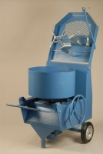 | ELE Concrete Mixer 56/40 Litre Capacity.  Code: 34-3540/01  Attributes: Voltage Supply = 220 - 240 V 50 Hz  Standards:

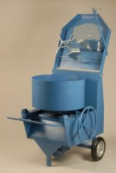 | ELE Concrete Mixer 56/40 Litre Capacity.  Code: 34-3540/06  Attributes: Voltage Supply = 220 - 240 V 60 Hz  Standards:

