Rice Test Vibrator
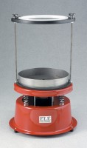 | Rice Test Vibrator  Code: 45-9315/01  Attributes: Description = Rice Test Vibrator 220 - 240 V AC 50 Hz, Dimensions, h x dia, ” = 19-1/2 x 12  Standards: EN 12697-5, ASTM D2041, AASHTO T209

 | Attachment Required for 6000 g  Code: 45-9315/10  Attributes: Description = Attachment required for Rice Test Vibrator  Standards: EN 12697-5

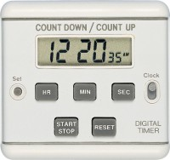 | Timer Clock  Code: 81-0518  Attributes: Description = Timer Clock, Main body length, arm, operating length mm = 13 x 64 x 58  Standards: EN 12697-5

