Shrinkage Prong Plate
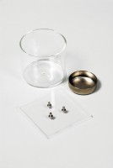 | Glass Cup.  Code: 24-1600  Attributes: Description = Glass cup, Weight, lbs = 0.388  Standards: ASTM D427, AASHTO T92

Prong Plate.
Code: 24-1500
Attributes: Description = Prong plate, Prong Plate Dimensions sq x thickness, ” = 3 x 1/8
Standards: BS 1377, ASTM D427, AASHTO T92

Shrinkage Dish.
Code: 24-1550
Attributes: Description = Shrinkage dish, Dimensions w x d x h, ” = 32x40x14 mm
Standards: ASTM D427, AASHTO T92

