Loss-on-Ignition
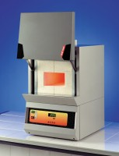 | Muffle Furnace  Code: 83-4170/01  Attributes: Description = Muffle Furnace, Voltage Supply = 220 – 240 V AC, 50/60 Hz, 1 ph  Standards: EN 196-2, EN 459-2, EN 13454-2, BS 1016-4, ISO 344, ISO 1171, ASTM D2361, ASTM D2795, ASTM D3714

 | Porcelain Crucible  Code: 82-3320  Attributes: Description = Porcelain Crucible, Capacity, ml = 30  Standards:

