Combination Permeameter Constant or Falling Head
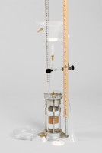 | Combination Permeameter  Code: 25-0623  Attributes: Description = Combination permeameter, Falling Head = Graduated pipette; 100 cc x 0.2 cc; 100 cm. maximum<br>head.  Standards:

 | Porous Stone 2.47" x .50"  Code: T-308  Attributes: Diameter, ” = 2.47, Description = Porous Stone 2.47″ x .50″  Standards:

