Tri-Flex 2 One-Cell Permeability Test System
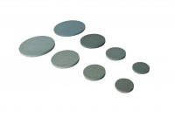 | Porous Stones 2.8"  Code: 25-6721  Attributes: Description = Porous disc 2.8″, Diameter, ” = 2.8"  Standards: ASTM D2850, ASTM D4767, ASTM D5084, AASHTO T296, AASHTO T297, ASTM D7181

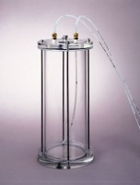 | Tri-Flex 2 Water De-airing Tank System  Code: 25-0698  Attributes: Capacity, gals = 1.4, Description = Tri-Flex 2 Water De-airing Tank System  Standards: ASTM D2850, ASTM D4767, ASTM D7181, ASTM D5084, AASHTO T296, AASHTO T297

 | Tri-Flex 2 Control Panel  Code: 25-0696/0x  Attributes: Description = Tri-Flex 2 Control Panel  Standards:

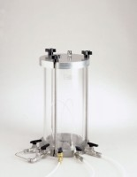 | Tri-Flex 2 Permeability Test Cell  Code: 25-0690  Attributes: Maximum Pressure, psi = 150, Description = Tri-Flex 2 Permeability Test Cell  Standards: ASTM D5084

ADU
Code: 27-1495/02
Attributes: Description = ADU
Standards:

Permeability Software
Code: 27-1765
Attributes: Weight, lbs = 1.1, Description = Permeability Software
Standards:

Membrane Tester 2.8"
Code: 25-6443
Attributes: Diameter, ” = 2.8", Description = Membrane Tester 2.8″
Standards:

Membrane Sealing Rings 2.8"
Code: 25-6641
Attributes: Diameter, ” = 2.8", Description = Membrane Sealing Rings 2.8″
Standards: ASTM D2850, ASTM D4767, ASTM D5084, AASHTO T296, AASHTO T297

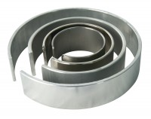 | Membrane Placing Tool 70mm/2.8 Inch Diameter.  Code: 25-6470  Attributes: Description = 70mm/2.8 Inch Membrane Placing Tool, Sample diameter = 70 mm, Diameter, ” = 2.8"  Standards:

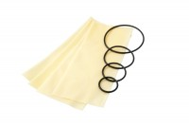 | Rubber Membrane 70mm/2.8 Inch Diameter. Pack of 10.  Code: 25-6441  Attributes: Description = Rubber Membrane 2.8", Sample diameter = 70 mm, Thickness, ” = 0.012  Standards: ASTM D2850, ASTM D4767, ASTM D5084, AASHTO T296, AASHTO T297, ASTM D7181

Suction Membrane Device 70mm Diameter.
Code: 25-6480
Attributes: Description = 70mm Suction Membrane Device, Sample diameter = 70 mm, Diameter, ” = 2.8"
Standards:

Acrylic Cap and Base Set 2.8"
Code: 25-0690/15
Attributes: Diameter, ” = 2.8", Description = Acrylic Cap and Base Set 2.8″
Standards: ASTM D5084

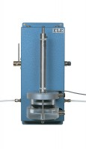 | Volume Change Transducer Assembly 80Cm3 Capacity Maximum Working Pressure 1700Kpa  Code: 27-1641  Attributes: Description = Volume change transducer assembly, Maximum Pressure, psi = 250  Standards:

Pressure Transducer Assembly 1700Kpa Fitted with 5 Pin Din Plug.
Code: 27-1633
Attributes: Description = Pressure transducer, Thread = 1 / 4
Standards:

