ELE Buoyancy Balance
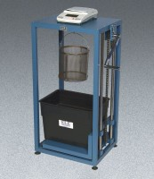 | ELE Buoyancy Balance  Code: 42-1000/02  Attributes: Rated Power = 110-120vAC, 50/60 Hz, 1ø., Description = ELE Buoyancy Balance  Standards: ASTM C127, AASHTO T85

 | Density Basket  Code: 42-1003  Attributes: Dimensions, diameter x height ” = 8” x 8”, Description = Density Basket  Standards: ASTM C127, AASHTO T85

