Large Capacity Sample Splitter
 | Sample Bag - 10” x 18” (254 x 457 mm)  Code: 23-1420  Attributes: Dimensions w x d x h, ” = 10x18, Description = Sample Bag - 10” x 18” (254 x 457 mm)  Standards:

Sample Bag - 17” x 32” (432 x 813 mm)
Code: 23-1422
Attributes: Dimensions w x d x h, ” = 17x32, Description = Sample Bag - 17” x 32” (432 x 813 mm)
Standards:

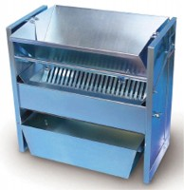 | Large Capacity Sample Splitter.  Code: 23-3425  Attributes: Description = Sample Splitter, Material Pans = Two included; 25 -3/4” l. x 9” w. x 6-1/2” h. (654 x 22 9 x 165 mm).  Standards:

Material Catch Pan for Sample Splitter 23-3425
Code: 23-3425/10
Attributes: Description = Material Catch Pan for Sample Splitter 23-3425
Standards:

