Asphalt Penetrometer
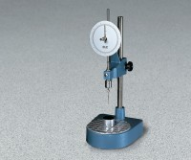 | Standard Penetrometer  Code: 46-5290  Attributes: Description = Standard Penetrometer  Standards: BS 2000-49, EN 1426, EN 13179-2, IP 49, ASTM D5, AASHTO T49

 | ASTM (Non-Certified) Penetration Needle  Code: 46-5290/10  Attributes: Description = ASTM (Non-Certified) Penetration Needle  Standards:

ASTM (NIST Certified) Penetration Needle
Code: 46-5297
Attributes: Description = ASTM (NIST Certified) Penetration Needle
Standards:

Transfer Dish
Code: 46-5800
Attributes: Description = Transfer Dish
Standards: BS 2000-49, EN 1426, EN 13179-2, ASTM D5, AASHTO T49, IP 49

