Vibrating Poker
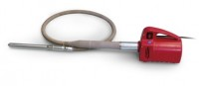 | Vibrating Poker 25mm Dia Tip 290mm Long. 220-240V 50/60Hz 1Ph.  Code: 34-6431/01  Attributes: Voltage Supply = 220 - 240 V AC, 50 - 60 Hz, 1 ph  Standards:

