Distilled Water Still
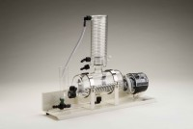 | Distilled Water Still  Code: 82-8020/01  Attributes: Voltage Supply = 220 - 240 V AC, 50/60 Hz, 1 ph  Standards:

