Automatic Compaction
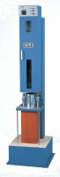 | AutoComp 100-A  Code: 45-6600/01  Attributes: Description = AutoComp 100-A, Power Supply = 220 - 240 V AC, 50 Hz, 1 ph  Standards: EN 12697-10, EN 12697-30

