Kjedahl apparatus
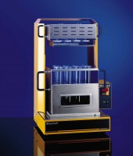 | Digestion Unit 8 place, semi-auto c/w block,rack, heat shield, exhaust,  Code: 525-355/01  Attributes: Description = Digestion Unit 8 place  Standards:

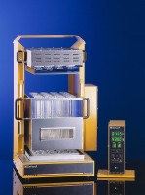 | Digestion Unit 20 Place Semi-Auto C/W Block Rack Heat Shield Exhaust Console & 250Ml Tubes  Code: 525-356/01  Attributes: Description = Digestion Unit 20 Place  Standards:

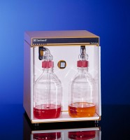 | Turbosog fume scrubber 220-240V 50/60Hz 1ph  Code: 525-370/01  Attributes: Description = Turbosog fume scrubber  Standards:

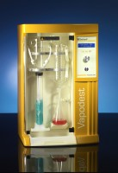 | Automatic distillation unit 220-240V 50/60Hz 1ph  Code: 525-375/01  Attributes: Description = Automatic distillation unit  Standards:

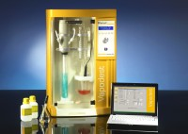 | Automatic distillation & titration system 220-240V 50/60Hz 1ph  Code: 525-380/01  Attributes: Description = Automatic distillation & titration system  Standards:

 | Digestion Tube Macro 250Ml  Code: 525-355/10  Attributes: Description = Digestion Tube Macro 250Ml  Standards:

Storage tanks for automatic distillation units-set of 3
Code: 525-376
Attributes: Description = Storage tanks for automatic distillation unit
Standards:

Spare Parts Kit for 525-380/01 for 2 Years Operation.
Code: 525-384
Attributes: Description = Spare Parts Kit for Automatic distillation & titration system
Standards:

