Sand Absorption Cone and Tamper
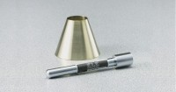 | Sand Absorption Cone and Tamper  Code: 42-1725  Attributes: Tamper = Steel; 1” diam. working face x 6-5/8” l. (25 .4 x 168 mm);<br>12 oz.(34 0 g) weight., Description = Sand Absorption Cone and Tamper  Standards: ASTM C128, AASHTO T84

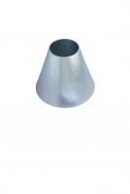 | Sand Absorption Cone.  Code: 42-1700  Attributes: Description = Sand Absorption Cone, Dimensions, diameter x height ” = 90 mm x 75 mm  Standards: BS 812, ASTM C128, AASHTO T84

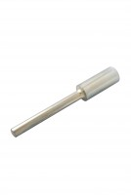 | Tamping Rod.  Code: 42-1720  Attributes: Description = Tamping Rod, Dimensions, diameter x height ” = 25.4 mm x 168 mm  Standards: BS 812, ASTM C128, AASHTO T84

