Basic Auger Kit
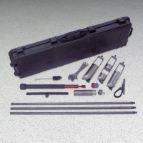 | Basic Auger Kit  Code: 23-1378  Attributes: Components = Cross handle, cleaning brush, wrenches., Description = Basic Auger Kit  Standards:

