Watches and Clocks
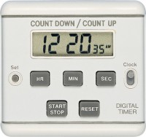 | Timer Clock  Code: 81-0518  Attributes: Description = Timer Clock, Main body length, arm, operating length mm = 13 x 64 x 58  Standards: EN 12697-5

 | Stopwatch  Code: 81-0521  Attributes: Description = Stopwatch, Main body length, arm, operating length mm = 20 x 60 x 80  Standards:

