Printing of results
 | Paper Roll 76mm Wide (Box of 20)  Code: 37-4859/12  Attributes: Description = Paper Roll  Standards:

Printer Ribbon(Black/Red) for Use with Impact Printer.
Code: 37-4859/10
Attributes: Description = Printer Ribbon
Standards:

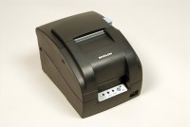 | Impact Printer Rs232 Serial Connection. Supplied Complete with 1 Paper Roll.  Code: 37-4859/02  Attributes: Description = Impact Printer RS232 Serial Connection  Standards:

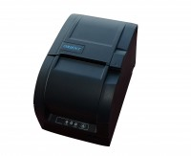 | Impact Printer Rs232 Serial Connection. Supplied Complete with 1 Paper Roll.  Code: 37-4859/01  Attributes: Description = Impact Printer  Standards:

