In-situ CBR
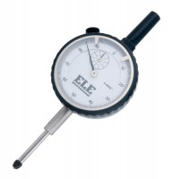 | Penetration/Swell Dial Gauge ASTM.  Code: 24-9184  Attributes: Description = Penetration/swell gauge ASTM  Standards:

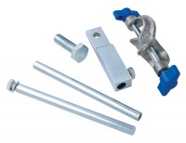 | Bracket and Adaptor. Dual Purpose Mounting Bracket for CBR Penetration Gauges EL24-9184/EL24-9186  Code: 24-9188  Attributes: Description = Bracket and adaptor  Standards:

Penetration Dial Gauge BS
Code: 24-9186
Attributes: Description = Penetration dial gauge - BS
Standards:

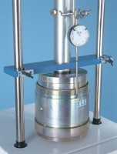 | Cbr Penetration Piston (Adjustable).  Code: 24-9183  Attributes: Description = Penetration Piston - with adjustment  Standards:

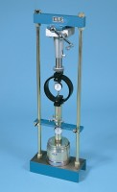 | 45kN (10000Lb) Capacity Mechanical Jack.  Code: 24-9290  Attributes: Description = 45 kN (10000 lb) capacity mechanical jack  Standards:

 | Land Rover Bracket to Attach EL29-200 Jack. for Land Rovers Models 90 & 110 From 1983 Onwards.  Code: 24-9298  Attributes: Description = Land Rover bracket  Standards:

Ball Seating for EL 24-9290 45 kN Jack
Code: 24-9300
Attributes: Description = Ball seating attachment
Standards:

Set of Extension Rods Complete
Code: 24-9308
Attributes: Description = Set of extension rods
Standards:

Datum Bar Assembly.
Code: 24-9312
Attributes: Description = Datum bar assembly
Standards:

10Lb (4.5Kg) Annular Surcharge Weight.
Code: 24-9320
Attributes: Description = 10 lb (4.5Kg) annular surcharge weight, Weight, kg = 4.5
Standards:

10Lb (4.5Kg) Slotted Surcharge Weight.
Code: 24-9322
Attributes: Description = 10 lb (4.5Kg) slotted surcharge weight, Weight, kg = 4.5
Standards:

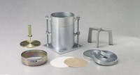 | 9.1Kg (20 Lb) Slotted Surcharge Weight (Cbr).  Code: 24-9248  Attributes: Description = Slotted Surcharge Weight 20 lb, Finish = Plated  Standards:

