Accessories for CU/CU effective stress
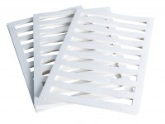 | Filter Paper Drain 38mm/1.5 Inch Diameter. Pack of 50.  Code: 25-5200  Attributes: Description = Filter paper drain 38 mm  Standards:

Filter Paper Drain 50mm Diameter. Pack of 50
Code: 25-5580
Attributes: Description = Filter paper drain 50 mm
Standards:

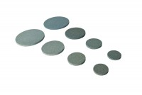 | Porous Disc 70mm Diameter Pack of 2.  Code: 25-6561  Attributes: Description = Porous disc 70 mm, Diameter, ” = 70 mm  Standards: ASTM D2850, ASTM D4767, ASTM D5084, AASHTO T296, AASHTO T297, ASTM D7181

Porous Disc 38mm/1.5 Inch Diameter. Pack of 2.
Code: 25-5181
Attributes: Description = Porous disc 1.5"
Standards:

Porous Disc 50mm Pack of 2
Code: 25-5561
Attributes: Description = Porous disc 50 mm
Standards:

Porous Disc 100mm Diameter Pack of 2.
Code: 25-7661
Attributes: Description = Porous disc 100 mm, Diameter, ” = 100 mm
Standards: ASTM D2850, ASTM D4767, ASTM D5084, AASHTO T296, AASHTO T297, ASTM D7181

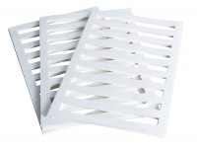 | Filter Paper Drain 70mm/2.8 Inch Diameter. Pack of 50.  Code: 25-6580  Attributes: Description = Filter paper drain 70 mm, Diameter, ” = 2.8"  Standards: ASTM D2850, ASTM D4767, ASTM D7181, AASHTO T296, AASHTO T297

Filter Paper Drain 100mm/4 Inch Diameter. Pack of 50.
Code: 25-7670
Attributes: Description = Filter paper drain 100mm, Diameter, ” = 4.0"
Standards: ASTM D2850, ASTM D4767, ASTM D7181, AASHTO T296, AASHTO T297

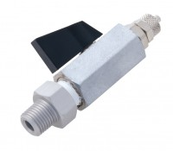 | Valve No Volume Change 1/4 Inch BSp Fitted with 6 mm Connector and Integral Sealing Ring.  Code: 25-4520  Attributes: Description = No volume change valve, Weight, lbs = 0.292  Standards: ASTM D2850, ASTM D4767, ASTM D7181, AASHTO T296, AASHTO T297

