Concrete Curing Tanks
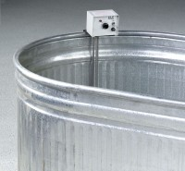 | Concrete Curing Tank  Code: 34-6763  Attributes: Description = Concrete Curing Tank 182 Gal., Dimensions, l x w x h, ” = 72 x 30 x 24  Standards:

Concrete Curing Tank
Code: 34-6764
Attributes: Description = Concrete Curing Tank 300 Gal., Dimensions, l x w x h, ” = 96 x 36 x 24
Standards:

