Blaine Fineness Apparatus
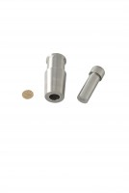 | Blaine Air Permeability Cell  Code: 38-1000/15  Attributes: Description = Blaine Air Permeability Cell  Standards: ASTM C204

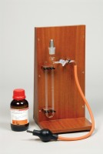 | Blaine Air Permeability Apparatus  Code: 38-1000  Attributes: Description = Blaine Air Permeability Apparatus, Weight, lbs = 7  Standards: EN 196-6, EN 459-2, EN 13286-44, BS 4359-2, ASTM C204, AASHTO T153

 | Reference Cement  Code: 38-0640  Attributes: Description = Reference Cement  Standards: ASTM C204, AASHTO T153

Filter Paper
Code: 38-0652
Attributes: Description = Filter Paper
Standards:

Manometer U-tube
Code: 38-1000/10
Attributes: Description = Manometer U-Tube
Standards: ASTM C204

Manometer Liquid
Code: 38-0620
Attributes: Description = Manometer Liquid
Standards: EN 196-21, ASTM C204

