Conversion of In-situ to Laboratory CBR
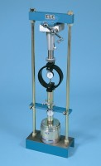 | Conversion Frame.  Code: 24-9341  Attributes: Description = 50 kN conversion frame, Weight, kg = 53  Standards:

45kN (10000Lb) Capacity Mechanical Jack.
Code: 24-9290
Attributes: Description = 45 kN (10000 lb) capacity mechanical jack
Standards:

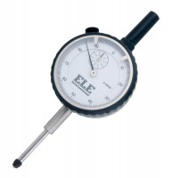 | Penetration/Swell Dial Gauge ASTM.  Code: 24-9184  Attributes: Description = Penetration/swell gauge ASTM  Standards:

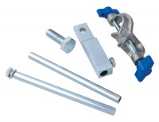 | Bracket and Adaptor. Dual Purpose Mounting Bracket for CBR Penetration Gauges EL24-9184/EL24-9186  Code: 24-9188  Attributes: Description = Bracket and adaptor  Standards:

Penetration Dial Gauge BS
Code: 24-9186
Attributes: Description = Penetration dial gauge - BS
Standards:

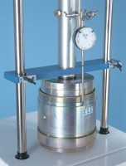 | Cbr Penetration Piston (Adjustable).  Code: 24-9183  Attributes: Description = Penetration Piston - with adjustment  Standards:

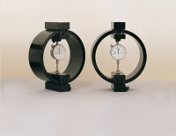 | Clamped Boss Load Ring - 28.0 kN  Code: 78-0760  Attributes: Description = Load ring - 28 kN, Load device type = Load ring, Force Capacity, kN = 28, Value of CBR % = Average range of CBR, Overall Height, mm = 248  Standards:

