Rock Classification Hammer
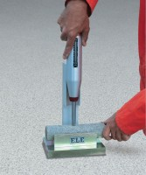 | Rock Classification Hammer  Code: 77-0470  Attributes: Weight, lbs = 3, Description = Rock Classification Hammer  Standards:

NW Rock Cradle
Code: 77-0480
Attributes: Core Size = NW size specimens, Description = NW Rock Cradle
Standards:

