BS EN consolidation cells and accessories
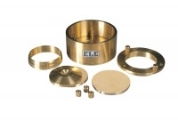 | Consolidation Cell Complete 75mm Diameter Sample  Code: 25-0503  Attributes: Description = Consolidation cell 75 mm, Sample diameter = 75 mm, Stress for 1 kg, kPa = 20  Standards: BS 1377, EN 1997-2

75mm Dia Upper and Lower Porous Stones for Use on EL25-0503 Series Cell.
Code: 25-0503/13
Attributes: Description = Upper and lower porous stones, Sample diameter = 75 mm, Weight, lbs = 0.6
Standards: BS 1377, EN 1997-2

Cutting Ring 75mm Cell.
Code: 25-0506
Attributes: Description = Cutting ring, Sample diameter = 75 mm, Weight, lbs = 0.22
Standards: BS 1377, EN 1997-2

Calibration Disc 75mm Cell
Code: 25-0509
Attributes: Description = Calibration disc, Sample diameter = 75 mm, Weight, lbs = 4.44
Standards: BS 1377, EN 1997-2

