Post Hole Augers (Iwan Type)
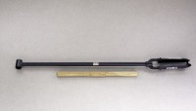 | 3" Diameter Post Hole Auger  Code: 23-1391  Attributes: Shaft length, ” = 36, Description = 3″ Diameter Post Hole Auger  Standards:

4" Diameter Post Hole Auger
Code: 23-1392
Attributes: Shaft length, ” = 36, Description = 4″ Diameter Post Hole Auger
Standards:

6" Diameter Post Hole Auger
Code: 23-1393
Attributes: Shaft length, ” = 36, Description = 6″ Diameter Post Hole Auger
Standards:

 | Auger Extension 36"  Code: 23-1397  Attributes: Weight, lbs = 3, Description = Auger Extension 36″  Standards:

3" Blade Head Assembly
Code: 23-1391/10
Attributes: Diameter, ” = 3, Description = 3″ Blade Head Assembly
Standards:

