Core Drill
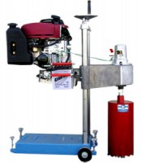 | Portable Core Drill, 17 hp, gasoline engine  Code: 47-5182  Attributes: Column Travel = 24" (610 mm), Description = Portable Core Drill, 17 hp, gasoline engine  Standards:

