Microbiological starter packs and consumables
 | Coliform Starter Pack. Sufficient for 200 Tests  Code: 422-010  Attributes: Description = Coliform Starter Pack  Standards:

Faecal Streptococci Starter Pack Sufficient for 200 Tests.
Code: 422-020
Attributes: Description = Faecal Streptococci Starter Pack
Standards:

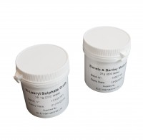 | Membrane Lauryl Sulphate Medium 38.1 Gram Pack. Sufficient for 200 Tests.  Code: 422-110  Attributes: Description = Membrane Lauryl Sulphate Medium Pack  Standards:

Slanetz and Bartley Medium. 21G Pack. Sufficient for 200 Tests.
Code: 422-120
Attributes: Description = Slanetz and Bartley Medium Pack
Standards:

Sterile Filter Membranes and ABSorbent Pads. Pack of 200.
Code: 422-508
Attributes: Description = Sterile Filter Membranes and Absorbent Pads x200
Standards:

Sterile Filter Membranes and ABSorbent Pads. Pack of 1000.
Code: 422-510
Attributes: Description = Sterile Filter Membranes and Absorbent Pads x1000
Standards:

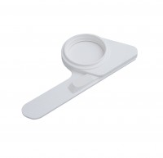 | Pad Dispenser.  Code: 422-515  Attributes: Description = Pad Dispenser  Standards:

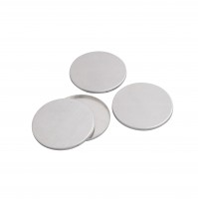 | Aluminium Petri Dishes Pack of 25.  Code: 422-560  Attributes: Description = Aluminium Petri Dishes  Standards:

Sterile Plastic Petri Dishes. Pack of 200.
Code: 422-569
Attributes: Description = Sterile Plastic Petri Dishes x200
Standards:

Sterile Plastic Petri Dishes. Pack of 700.
Code: 422-570
Attributes: Description = Sterile Plastic Petri Dishes x700
Standards:

