Prism Moulds and Inserts
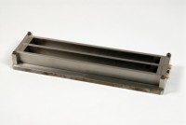 | Two Gang Prism Mould Produces 1 Inch Square X 11 1/4 Inch Long Specimen (10 Inch Gauge Length)  Code: 34-8544  Attributes: Description = Two Gang Prism Mould 1" x 11 1/4", Gauge Length = 10” (254 mm) between inner ends of embedded contact points.  Standards: ASTM C141, ASTM C151, ASTM C157, ASTM C227, ASTM C490, ASTM C531, AASHTO T107

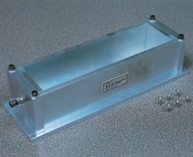 | Prism Mould 75 X 75 X 254mm  Code: 34-8538  Attributes: Description = Prism Mould 75 x 75 x 254 mm, Weight, kg = 6.5  Standards:

 | Steel Inserts for El34-8538 (Pack of 10)  Code: 34-8541  Attributes: Description = Steel Inserts for prism mould 75 x 75 x 254 mm, Weight, kg = 0.5  Standards:

Inserts for 34-8544 (Pack of 10)
Code: 34-8547
Attributes: Description = Inserts for Prism Mould 1" x 11 1/4", Weight, kg = 0.7
Standards:

 | Humidity Cabinet to En196 320 Litre Capacity  Code: 39-1300/01  Attributes: Description = Humidity Cabinet, Capacity, litres = 320, Voltage Supply = 220 - 240 V AC, 50 Hz, 1 ph, Power Supply = 220-240 V AC, 50 Hz, 1 ph  Standards: EN 196-1, EN 459-2, BS 3892-1

