Rapid-Change Block Platen Sets
 | Platen Set for Blocks up to 10"  Code: 37-5520  Attributes: Description = Platen Set for Blocks up to 10″, Dimensions, l x w x h, ” = 14 x 10 x 8.25  Standards:

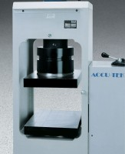 | Platen Set for Blocks up to 12"  Code: 37-5518  Attributes: Description = Platen Set for Blocks up to 12″, Dimensions, l x w x h, ” = 16 x 12 x 10.5  Standards:

