Tall Non-Vacuum, Dessicator Cabinet
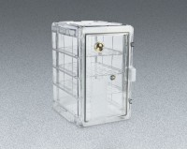 | Desiccator Cabinet  Code: 88-6700  Attributes: Description = Desiccator Cabinet  Standards:

 | Drierite Desiccant  Code: 45-9315/14  Attributes: Description = Drierite Desiccant  Standards:

