Rapid-Change Cube Platen Sets
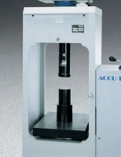 | Platen Set for 2" Cubes  Code: 37-5510  Attributes: Dimensions, diameter x length, ” = 4 x 16.75, Description = Platen Set for 2″ Cubes  Standards: ASTM C109, ASTM C39, AASHTO T22

 | Upper Platen, 6" (150 mm) Cubes  Code: 37-5566  Attributes: Description = Platen Set for 6" Cubes  Standards:

