Asphalt Flow Indicator with Brake
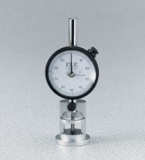 | Asphalt Flow Indicator with Brake - English  Code: 45-6892  Attributes: Weight, oz. = 12, Description = Asphalt Flow Indicator with Brake - English  Standards: ASTM D6927, AASHTO T245

Asphalt Flow Indicator with Brake - Metric
Code: 45-6894
Attributes: Weight, oz. = 12, Description = Asphalt Flow Indicator with Brake - Metric
Standards: ASTM D6927, AASHTO T245

