Melting Pot
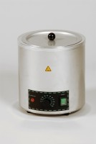 | Melting Pot 4 Litre Capacity. 50 to 300 Deg. C. Temperature Range.  Code: 34-6122/01  Attributes: Voltage Supply = 220 - 240 V AC, 50 - 60 Hz, 1 ph  Standards:

