Porous Stones
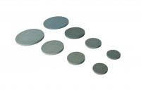 | 1.4" Porous Stones  Code: 25-4461  Attributes: Description = Porous disc 1.4″, Diameter, ” = 1.4"  Standards: ASTM D2850, ASTM D4767, ASTM D5084, AASHTO T296, AASHTO T297, ASTM D7181

Porous Stones 2.8"
Code: 25-6721
Attributes: Description = Porous disc 2.8″, Diameter, ” = 2.8"
Standards: ASTM D2850, ASTM D4767, ASTM D5084, AASHTO T296, AASHTO T297, ASTM D7181

4.0" Porous Stones
Code: 25-7761
Attributes: Description = Porous disc 4.0″, Diameter, ” = 4.0"
Standards: ASTM D2850, ASTM D4767, ASTM D5084, AASHTO T296, AASHTO T297, ASTM D7181

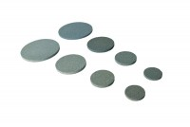 | Porous Disc 70mm Diameter Pack of 2.  Code: 25-6561  Attributes: Description = Porous disc 70 mm, Diameter, ” = 70 mm  Standards: ASTM D2850, ASTM D4767, ASTM D5084, AASHTO T296, AASHTO T297, ASTM D7181

Porous Disc 38mm/1.5 Inch Diameter. Pack of 2.
Code: 25-5181
Attributes: Description = Porous disc 1.5"
Standards:

Porous Disc 50mm Pack of 2
Code: 25-5561
Attributes: Description = Porous disc 50 mm
Standards:

Porous Disc 100mm Diameter Pack of 2.
Code: 25-7661
Attributes: Description = Porous disc 100 mm, Diameter, ” = 100 mm
Standards: ASTM D2850, ASTM D4767, ASTM D5084, AASHTO T296, AASHTO T297, ASTM D7181

