Particle Density (specific gravity) and Water Absorption for Coarse Aggregates
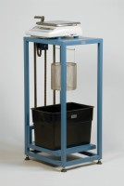 | Buoyancy Balance 6Kg X 0.1G. Supplied with Support Frame Water Tank & Suspension Hook.  Code: 42-1000/01  Attributes: Description = Buoyancy Balance, Power Supply = 220 - 240 V AC, 50 - 60 Hz  Standards: EN 1097-6, EN 12697-6, BS 812, ASTM C127, AASHTO T85

 | Wire Basket Brass with Handle Nominal 6000Cm³ Capacity with 1.7mm Wire Mesh.  Code: 42-1005  Attributes: Description = Wire Basket, Main body length, arm, operating length mm = 200 x 190  Standards: EN 1097-6, EN 12697-6, BS 812, ASTM C127, AASHTO T85

